**Abstract Floral Rings Metal Wall Art With LED**

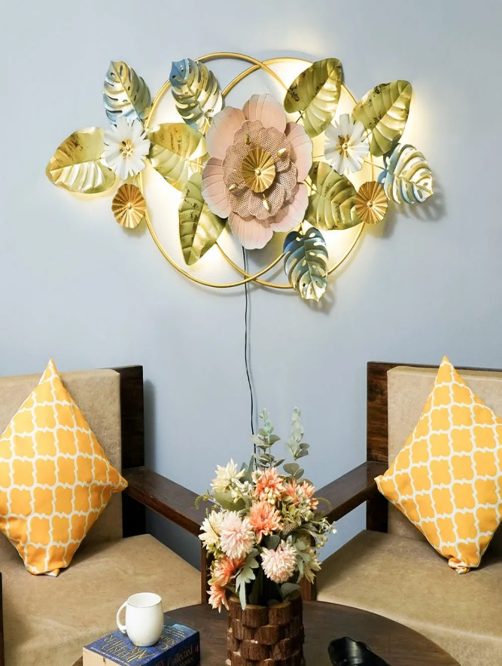Abstract floral rings metal wall art with LED is a modern and dynamic decor piece that combines intricate design with illuminating functionality. The artwork features a series of abstract floral shapes encased in circular rings, crafted from metal for a sleek and contemporary look. Integrated LED lighting enhances the design, casting a soft, ambient glow around the floral patterns, creating a mesmerizing visual effect. The combination of metal and light adds a sense of depth and sophistication, making this piece a perfect addition to living rooms, dining areas, or entryways. Its unique fusion of art and technology transforms any space into a chic and welcoming environment.